Stories of Accomplishment

This session is not intended to help participants engage in a full inventory of their vocational skills; rather, it is designed to help them identify some of the skills they most enjoy using and to begin to practice communication their strengths. An added benefit of this session is that it helps to further develop participants’ sense of self-efficacy, through revisiting personal accomplishments and hearing their strengths reflected back to them by facilitators and peers.
This session tends to be highly effective in building group cohesion and mutual support. It is important, however, that during the storytelling portion of the activity (part II) each group have a staff facilitator. This will allow facilitators to model the feedback process and provide gentle guidance when a participant has trouble generating or communicating feedback.
By the end of the session, participants will be able to identify and describe personal accomplishments and identify skills used in past experiences.

AGENDA
- Discussion
- Activity I
- Break
- ..................Column Break..................Activity II
- Summary/Reflection
- Evaluations

WARM UP: GAME OF POSSIBILITIES
Explain to students that you’re asking them to engage in an unusual but fun warm up activity. Choose an ordinary object from the classroom. Ask for volunteers to think of a non-standard use for the object and pantomime it in front of the class. The person miming cannot speak.
Ideas should be original. For example, if a pencil is the chosen object, someone might mime using it as a last-bit-of toothpaste extractor (by rolling the tube w/ the pencil) or a muddy-show cleaner. The students watching should try to guess what the person is mining.
After a few volunteers have demonstrated their ideas, identify someone who volunteered as an example. Ask the students to brainstorm all the skills that the person used to engage in that activity. (Creativity, ingenuity, flexibility, resourcefulness, public presentation, physical coordination, concentration, etc.). Explain that today's class is about inferring skills from accomplishments – which means identifying the most important skills that were used in achieving some of our accomplishments. Make the point that the class already knows how to do this – they just engaged in inferring skills during the warm up.

DISCUSSION

Define concept. (See participant handout for definitions). Make sure to explain that the concept of a “skill” can be tricky, in that there are skills that seem more like personality traits (ex. persistence, flexibility, and adaptability). Assure participants that while some skills come more naturally to some than others, “soft” skills are still skills – they can still be learned and developed!
Establish rationale. Why dedicate an entire class to skills? When we know our strongest and most enjoyable skills, we are better equipped to identify work that is a good match for us and to promote ourselves to employers on paper and in person.

Emphasize the importance of identifying enjoyable skills. While we may possess a wide range
of skills, we don’t necessarily enjoy using all of them. In fact, our strong skills that we don’t
enjoy using are called “burnout” skills. It’s important to identify skills that we most enjoy using so that we can improve our likelihood of finding satisfying work opportunities.

Preview activity. One of the best ways to effectively identify our skills and communicate them to others is through revisiting our past accomplishments. Today, we’ll learn a method for doing this.

Break Activities
  - Listing Accomplishments (15 minutes)
    - Participants may find it helpful to refer to their vitas.
  - Inferring Skills from Accomplishments (60 minutes)
    - At the conclusion of this activity, direct students to fill out the skills portion of their summary profiles, either in class or at home.

SUMMARY/REFLECTION
Time permitting, have participants jot down a few reflections related to the activity. Helpful guiding questions might be: What did you learn about yourself today? What are three skills you possess and enjoy using? What will you take away from today’s session? Allow time for a few participants to briefly share their reflections.

EVALUATIONS

Skills & Accomplishments

A skill is a behavior you can learn how to do and is often directed towards a goal. Technical skills are specific and unique to a certain occupation. Examples of technical skills are taking blood pressure, changing oil in a car, or stocking shelves. Transferable skills are broad skills that can be applied to many lines of work.
Examples of transferable skills are listed below:

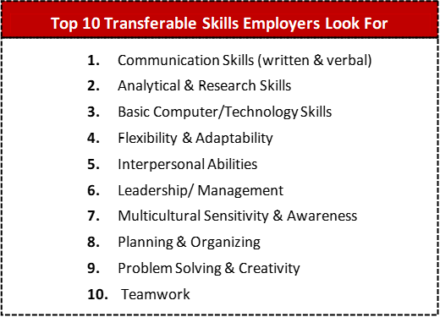

Listing My Accomplishments
Take a few minutes to list some of your accomplishments from the past 5- 10 years. Choose achievements that gave you a sense of satisfaction and pride (vs. activities that you did out of obligation or that felt like a chore). When it comes to long-term accomplishments, try to identify one or two significant, specific situations that occurred along the way (EXAMPLE: “Helped my son pass his math class” vs. “raised my son”).

Category | Brainstorm
Educational

Ex) Completed a class.
Work & Volunteer

Ex) Completed a project.
Relationships

Ex) Cared for sick family member.
Hobbies/Leisure

Ex) Created scrapbook.
Other Life Experiences

Ex) 2 years sober.

Telling My Story

Choose one accomplishment from your list that you would like to share with the group. When it is your turn to share, try to keep your story brief – less than 2 minutes. When you tell it, follow this format:
  - What did you do?
  - How did you do it? (What steps did you take?)
  - What were the results?

You can use the space below to jot down an outline of your story:

After each member of your group tells their story, on a notecard, write their name and the most important skills they used to achieve their accomplishment. (See next page for examples of skills). Then share your observations with the group (Your facilitator will model this process).

Examples of Skills

Personal Skills
Dependability, Flexibility, Persistence

Social Skills
Social Perception Teamwork Assisting/Caring

Movement Skills
Motor Coordination Stamina
Strength

Perceptual Skills
Visualizing Creativity

Situational Skills
Tolerating Stress Tolerating Discomfort

Processing Skills
Following Procedures Record Keeping Attention to Detail

.Technical Skills
Repairing
Using Computers Programming Troubleshooting

Math & Science Skills
Calculating Budgeting Estimating

Communication Skills
Reading Writing Speaking Listening Concentrating

Problem Solving Skills
Information Gathering Analyzing
Planning

Management Skills
Persuading Coordinating Directing/Leading Decision Making

Extension - Identifying Your Power Skills

In the space that follows, continue recording your stories of accomplishment. Just like we did in class, identify the most important skills you used in each of your accomplishments. This exercise will be helpful to creating a strong resume and cover letter, and constructing good answers to interview questions.

