Clarifying My Values

Helping people in recovery identify their values and make choices in accordance with them has been at the heart of vocational rehabilitation at the Center. We have preserved both the practice and the approach in Opening Doors. Current vocational counseling practice also recognizes the importance of helping people identify their vocational values, so in addition to the traditional psychiatric rehabilitation approach, we have incorporated some value-clarifying tools from mainstream online resources.
By the end of this session, participants will be able to identify and describe positive and negative work experiences, infer values from past experience, and list and define their top 5 vocational values.

AGENDA
- Discussion
- Break
- Activity
- Extension/At-Home Instructions
- Evaluations

WARM-UP
Give participants the opportunity to debrief around continuing to work on their vitas for HW.

DISCUSSION
Orient. Last session, we took time to identify and describe vocational experiences in a personal
vita. Today, we’ll use the information from our vitas to clarify our vocational values.
Rationale. Values are a central factor that shape someone’s vocational identity. Since values are highly personal, knowing our career-related values is key to knowing who we are as workers. Having this knowledge can help us to make informed choices about what kinds of work we might want to explore, whether a certain job will be a good fit for us, etc. When our career path is aligned with our values, we’re more likely to feel motivated and fulfilled in our work lives.
Define concept. Elicit participants’ understanding of the concept of a “value”; introduce distinction between core values and vocational values (see definitions on student handout). Ask participants to provide other examples of both types of values. Ask participants how a person’s core values and vocational values might be related (e.g., if a person’s core values include family, they might value work/life balance in a job).

Present O*NET values list. Direct participants to list of O*NET values (on handout).
This is a list of work values put together by the U.S. Department of Labor. (For those that don’t now, the DOL is a department of the federal government that is responsible for developing programs related to many aspects f work). While there are hundreds of work values, this is a list of twenty of the most common work values identified by workers in the U.S.
Ask participants whether any of these values immediately stand out to them. Direct
participants’ attention to the definitions that accompany the values list. Note that by the end of the class, participants will be composing a list of their top five vocational values, which will also include personal definitions. Their values list may include values other than the ones listed by O*NET. Direct participants to review the list and check off up to five values that immediately stand out as important to them.

Break Activity
(See instructions on participant handout). Encourage participants to choose experiences
they’ve had within the last five years. Give at least a couple examples of inferring values from positive and negative work experiences. You might walk through a participant’s example as a group before asking participants to work on their own.

EXTENSION/AT HOME INSTRUCTIONS
Define Your Vocational Values (see participant handout)
This will require explanation from the instructors. Come prepared with a few additional examples that demonstrate how to define vocational values. Help participants identify the observable signs that indicate the fulfillment of a particular value (i.e., stability looks like a full benefits package”, “freedom looks like being able to set my own schedule”.)

SUMMARY/REFLECTION
What did you learn about yourself today and how you view work? How will this knowledge help you as you continue forward in your exploration?

EVALUATIONS

Values

What is a Core Value?

A core value is a basic principal or standard that guides your life choices. Some examples of core values are acceptance, beauty, stability, family, loyalty. Some people say core values often “just feel like a part of themselves.” What are some of your core values? How do you know?

What is a Vocational Value?

A vocational or work value is a basic principal or standard that guides your work choices. Some examples of work values are stability, balance, independence, and achievement. Knowing your career-related values can help you to more skillfully navigate the world of work and consider options that are a better fit for you.

Identifying Our Values

On the next page is a list of 20 most common work values. Which values on the list matter most to you? How do you know? Do you notice any values that are missing from the list?

Adapted from “Career Planning Curriculum for People with Psychiatric Disabilities: Instructor’s Guide
(Danley, Hutchinson, & Restrepo-Toro, 1998)

O*Net Top 20 Values
O*NET Values | Definition | Cat.
Achievement | The work would give me a feeling of accomplishment | A
Ability Utilization | I could make use of my individual abilities | A
Creativity | I could try out my own ideas | I
Autonomy | I could plan my work with little supervision | I
Advancement | The job would provide an opportunity for promotion | REC
Recognition | I could receive recognition for the work I do | REC
Authority | I could give directions and instructions to others | REC
Social Status | I would be looked up to by others | REC
Co-Workers | My co-workers would be easy to get along with | REL
Social Service | I could do things for other people | REL
Moral Values | I wouldn’t be pressured to go against my morals | REL
Company Practices | I would be treated fairly by the company | S
Supervision, HR | Supervisors would back up their workers w/ management | S
Supervision, Tech | I would have supervisors who train their workers well | S
Activity | I could be busy all the time | WC
Independence | I could work alone | WC
Variety | I could do something different every day | WC
Compensation | My pay would compare well with that of other workers | WC
Security | The job would provide for steady employment | WC
Working Conds. | The job would have good working conditions | WC

Activity: Clarifying My Values

Positive Experiences

Directions:
  - Name a positive work, extracurricular, or volunteer experience on a card.
  - On the same side of that card, describe what it was about that experience that was positive (be specific).
  - On the other side of the card, apply a one or two word value name to that positive quality.
  - Repeat up to three times.

Negative Experiences

Directions:
- List a negative work, extracurricular, or volunteer experience on a card.
- On the same side of that card, describe what it was about that experience that bothered you (be specific).
- On the other side of the card, apply a one- or two-word name to the corresponding positive value you would prefer.
- Repeat up to three times.

Ranking Values

Directions:
- Create a new card for each of the values you circled on page 56 that were NOT identified in your positive/negative experiences.
- Sort your value cards into three categories: Most Important, Somewhat Important, Nice to Have.
- Limit the number of cards in your “Most Important” category to five.

Example: Clarifying My Values
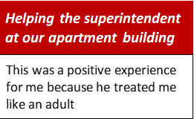

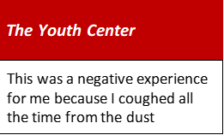

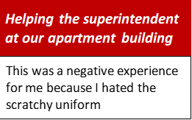

Extension: Define Your Vocational Values

Now record the value names that you placed in the Most Important category in your Summary Portrait on page 76. Give each value a personal definition. For example, if your value is “variety,” your definition could be something like “This means in a job that is a good match for me I would have varied responsibilities.” Use the space below to brainstorm.

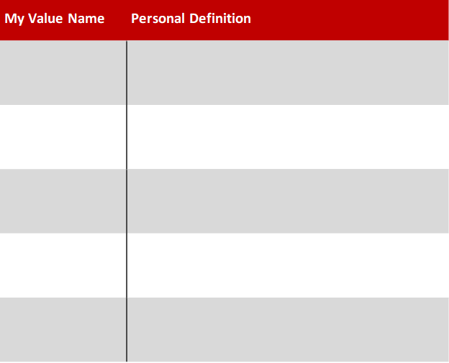

Extension: Search Occupations by Values

The US Department of Labor has grouped the 20 work values on page 56 into six overall categories. Those six categories are listed in the box below:
Achievement — Occupations that satisfy this work value category are
results oriented and allow employees to use their strongest abilities, giving them a feeling of accomplishment.
Independence — Occupations that satisfy this work value category allow employees to work on their own and make decisions.
Recognition — Occupations that satisfy this work value category offer advancement, potential for leadership, and are often considered prestigious.
Relationships — Occupations that satisfy this work value category allow employees to provide service to others and work with co-workers in a
friendly non-competitive environment.
Support — Occupations that satisfy this work value category offer supportive management that stands behind employees.
Working Conditions — Occupations that satisfy this work value offer job security and good working conditions.

Take a look at the values you circled on page 56. Did you check off more than one in a particular category?
O*NET is a free online website developed by the US Department of Labor. It includes a variety of tools that can help inform your career exploration process. If you go to the O*NET site, you can select up to three value categories (starting with your most important) and browse through matching occupations. Go to:
https://www.onetonline.org/find/descriptor/browse/Work_Values/

